**Daily Scrum or Standup Meeting**

Team name: 5th Element

Scrum Master: Leonardo Craven

Date: November 8, 2021

|  |  |  |  |
| --- | --- | --- | --- |
| **Team Member** | **What did you do since the last scrum?** | **What do you plan to do before the next scrum?** | **What obstacles do you have?** |
| Leo | Finish edit drink menu page | Work on drink order notification system (done Thursday)  Finish editing README.md (done today) | None |
| Gavin | Finish current drink orders for managers/bartenders page | Add current drink orders for players page (done tomorrow)  Add database population migration (done tomorrow) | None |
| Andrew (not present at meeting) |  |  |  |
| Brock | Worked on support for user money accounts | Finish support for user money accounts (done today)  Add company money account (done Wednesday) | None |

# Burndown

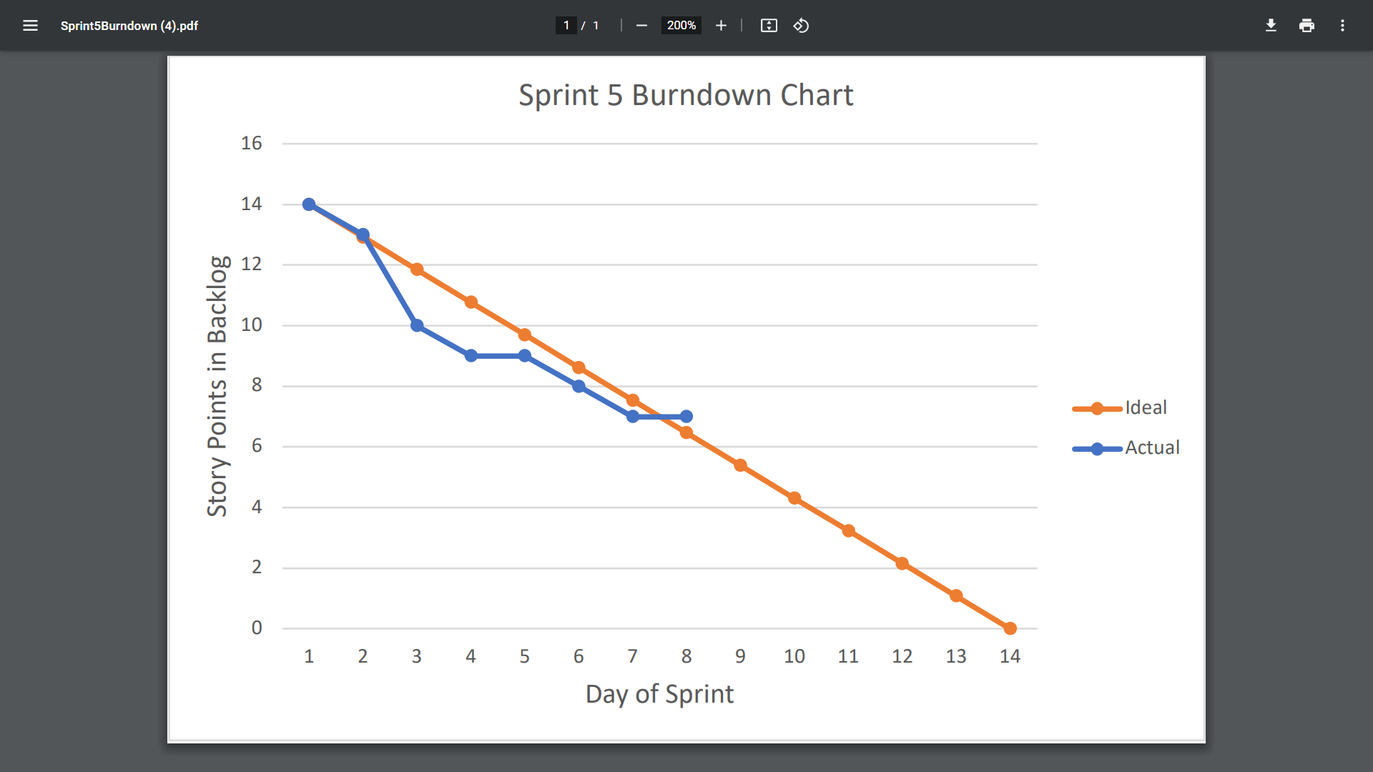

# Screenshot of you project board

